Rafid Sarowar

CIS-17C

26SPR-CIS-17C-42426

Project 2

What Is Ludo?

Ludo is a simple race-and-capture board game for 2 to 4 players. Each person rolls a single die to move their tokens from the “yard” onto a cross‑shaped track, aiming to bring all pieces safely home. Landing on an opponent’s token sends it back to its yard, combining luck and light strategy in every turn.

Origins and Evolution

Ludo traces its roots to the Indian game Pachisi (6th century AD), where cowrie shells and cloth boards defined royal pastimes. In 1896, British colonists formalized it as “Ludo” (Latin for “I play”), replacing shells with a cubical die and standardizing rules. From Britain, it spread worldwide, adapting to local materials and player styles.

Ludo in Bangladesh

In Bangladesh, লুডু boards—often plastic or chalk‑drawn—are staples of monsoon nights and festive gatherings. Families and neighbors crowd verandahs or street corners, sipping tea as dice clatter and laughter fills the air. Impromptu matches bridge generations, blending friendly rivalry with casual storytelling.

A Core Family Memory

Growing up in Bangladesh, Ludo was the game my brother, cousins, and I would always play. I must have whiled away thousands of monsoon‑drenched evenings clustered around that battered plastic board in our courtyard. Grandparents would hover, gently guiding our tokens; cousins would erupt in laughter after each cunning “cut”; and my grandmother’s soft scolds came whenever I forgot to say “thank you” after rolling a six. Those countless games—just dice, tokens, and shared stories—wove a bond between us that still brings a smile whenever I think back.

Project Overview

This project is a complete, modular, and professional C++ simulation of Ludo, redesigned from my previous CIS 5 project. The original CIS 5 version used arrays, functions, file I/O, searching, sorting, and other introductory programming concepts. For this CIS 17C version, the program has been rebuilt using the Standard Template Library to demonstrate container-based design and STL algorithms.

The project is developed across four versions, with each version adding new features and stronger STL usage. The final version supports 2-4 players, two tokens per player, dice rolling, turn management, safe tiles, cutting opponents, a triple-six penalty, move history, file logging, statistics, and a leaderboard.

The final program uses STL containers such as list, map, set, queue, stack, and deque. It also uses iterators and STL algorithms, including find_if, count_if, for_each, replace, remove_if, sort, min_element, and max_element. No vector is used in this project.

This project shows how a basic CIS 5 game can be transformed into a more advanced STL-based program with cleaner organization, better data management, and more professional structure.

GitHub Link: https://github.com/RafidSarowar/CIS-17C-

Version-by-Version Evolution

Each version builds on the last—see the pseudocode and code snippet for each.

Version 0.1: The Ultimate, Checklist-Full Ludo With CIS-5 Concept Implementations
Version 0.1 is the foundation of my CIS 17C Project 1. This version is based on my original CIS 5 Ludo project. It keeps the same game rules, player system, dice rolling, token movement, cut rule, triple-six penalty, file logging, statistics, and leaderboard logic. The purpose of this version is to document where the project started before converting the design into a Standard Template Library-based program. Since this version comes from CIS 5, it still uses arrays and basic procedural programming. Later versions replace those structures with STL containers such as list, map, set, queue, and stack.
Features:

Version 0.1 — Features
- Based on your original CIS 5 Ludo Project 2 Final Version
- Works as the baseline/start point for the CIS 17C STL project
- Keeps the original Ludo game idea before the full STL redesign
- Supports 2–4 players
- Each player has 2 tokens
- Players roll a six-sided die
- The player chooses which token to move
- Token positions are tracked on the board
- Tokens move toward the finish tile
- Finish tile is 50
- Uses a safe-stop rule, so tokens do not pass tile 50
- Includes the cut rule
- If a player lands on an opponent’s token, the opponent’s token goes back to start
- Includes a triple-six penalty
- If a player rolls three sixes in a row, they lose their turn
- Checks when a player wins
- First player to get both tokens to the finish wins
- Tracks player statistics
- Tracks number of moves
- Tracks number of turns
- Tracks number of cuts
- Shows final stats after the game
- Creates a leaderboard
- Writes game actions to a log file
- Writes leaderboard/results to a file
- Uses formatted console output
- Includes instructions for the player
- Uses clear comments to explain checklist items
- Serves as the “before” version before converting the project into STL containers
Key C++ Concepts: Starting version
- This is the original/base version of the Ludo game.
- It shows what the project looked like before the CIS 17C STL upgrades.
Ludo game
- A board game where players roll a die and move tokens.
- The first player to get both tokens to the finish wins.
Players
- The game allows 2–4 players.
- Each player has 2 tokens.
Dice rolling
- The program randomly rolls a number from 1 to 6.
Token movement
- The player chooses which token to move.
- The token moves based on the dice roll.
Cut rule
- If a player lands on another player’s token, that token goes back to start.
Triple-six rule
- If a player rolls three 6s in a row, they lose their turn.
Win check
- The program checks if both tokens reached the finish.
Stats
- Tracks moves, turns, and cuts for each player.
Leaderboard
- Shows player results at the end of the game.
File output
- Saves game actions and results to a file.
Functions
- The code is split into smaller functions like roll, move, print, and check win.
Arrays
- Uses arrays to store player tokens and stats.
Loops
- Uses loops for the game turns, player input, and printing results.
If statements
- Uses conditions to check rules, wins, cuts, and input.
Sorting and searching
- Uses basic manual sorting and searching for stats/leaderboard.
Main purpose
- Version 0.1 is the foundation.
- Later versions improve it by using STL containers like list, map, set, queue, and stack.
.

Pseudocode:

// --- [2.12, 2.13, 2.4, 2.6] Declare local variables, no globals

// Declare local constants: START, FINISH, MAXP, TOKS

// [3.1, 5.2, 5.5] Input number of players (do-while)

// [6.3, 6.5, 6.13, 6.12, 6.14] Function prototypes (pass by value, ref, defaulted, overloading)

// [7.1, 7.2, 7.8, 7.9, 7.12] Declare tokens[4][2], names[4], stats arrays, demo vector

// [2.15, 17] Output formatted instructions

// [5.6, 4.11] Main game loop: while (!win)

// [3.8, 2.7] Print formatted output

// [5.1, 5.2] Increment turn counters

// [3.7, 5.2] while for input validation

// [4.4, 4.5, 4.6] if, if-else, nesting

// [8.3, 8.4, 8.1] Sorting and searching functions

// [4.14] Switch statement for die face output

// [3.13] Logical operators (&&, ||)

// [4.13] Conditional operator (?:)

// [9.1, 3.9] Math library: pow, abs

// [6.11] static variable use in a function

// [6.15] exit() for clean exit after game over

// [7.5, 7.6] Pass arrays/vectors to functions

// [2.9] float use, no double

// [3.5] Type cast: static_cast

// [2.11] Use of bools

// [5.12] No breaks in loops

// [2.7] Formatted output (setw, setprecision)

Code Snippet:
Modular with functions—no arrays yet.
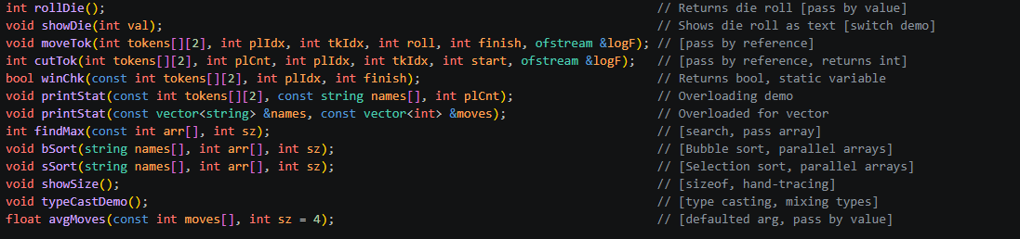

Version 1: Basic STL Conversion

New Features:

Version 1 begins the actual CIS 17C redesign.

The old array-based token system is replaced with STL containers.

list<int> stores each player’s token positions.

map<string, list<int>> connects a player name to that player’s tokens.

Iterators are used to iterate over maps and lists.

No vector is used.

The game is still simple on purpose, so the first STL change is clear.

Difference:

Version 0.1 stores tokens using arrays.

Version 1 stores tokens using a list.

Version 0.1 uses array indexes.

Version 1 uses STL iterators.

Version 0.1 separates player names and tokens.

Version 1 connects names and tokens with a map.

Pseudocode:

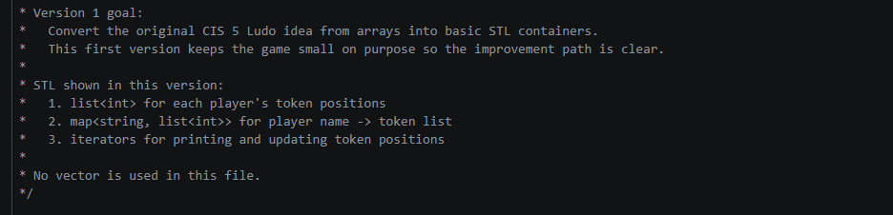

Code Snippet:
Creating Tokens with a list
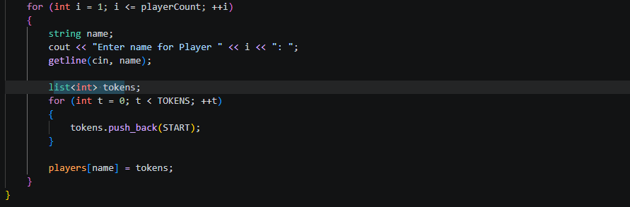

Iterator-Based Printing
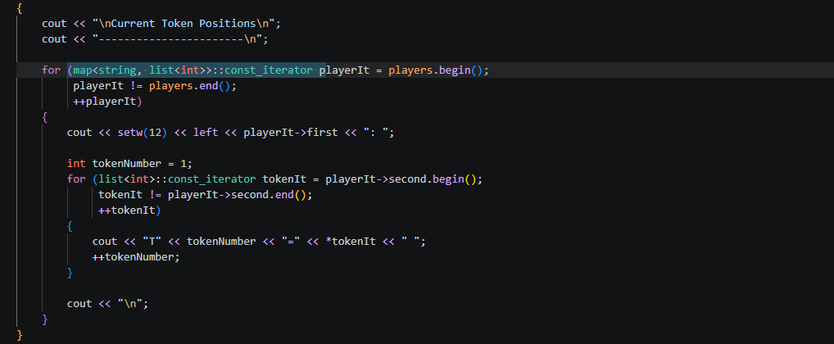

Version 2: Queue Turn Order and Safe Tiles
New Features:
- Version 2 improves the turn system.
- Instead of manually changing player indexes, the program uses a queue.
- queue<string> controls whose turn comes next.
- set<int> stores safe tiles.
- map<string, int> stores turn statistics.
- This version adds another associative container and a container adaptor.
Difference :
- Version 0.1 manually cycles players with an integer index.
- Version 2 uses a queue to manage turns more naturally.
- Version 0.1 would check safe tiles manually.
- Version 2 stores safe tiles in a set, which keeps unique safe positions.

Pseudocode:

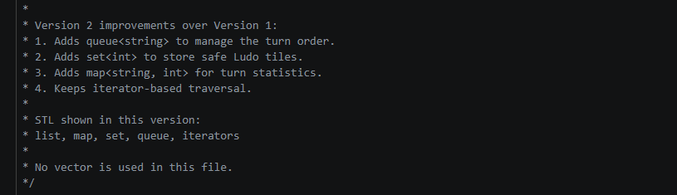

Code Snippet:
Better turn Counter:

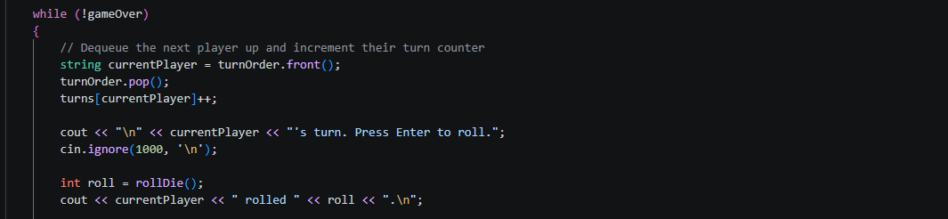
Tile style:
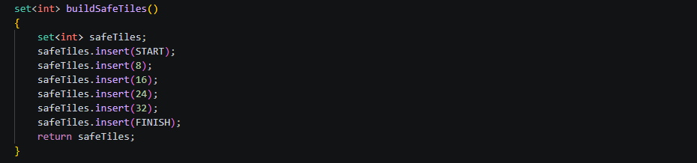

Version 3: Cut Rule, Move History, Logging, and Algorithms

Version 3 adds more real Ludo behavior.

The cut rule is added back in the STL version.

If a player lands on an opponent’s token, the opponent's token returns to the start.

stack<string> is used for move history.

File logging is added.

STL algorithms are introduced.

The token system becomes stronger by using a Token structure.

Instead of storing only integers, each token now has:

token number

position

Difference:

Version 1 stores only token positions.

Version 3 stores complete token objects.

Version 1 has no cut history.

Version 3 uses a stack to remember recent moves.

Version 3 begins using STL algorithms instead of only manual loops.

Pseudocode:

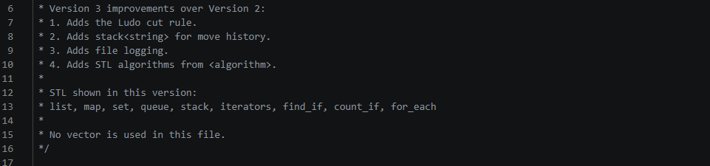

Code Snippet:
New Token Style:

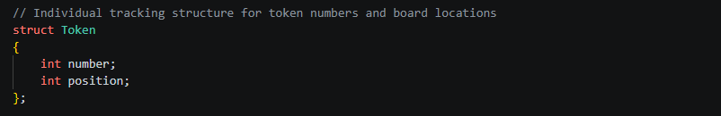

Move history in Version 3:
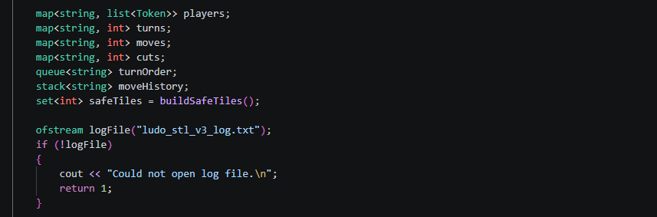

Algorithm Implementation Example:
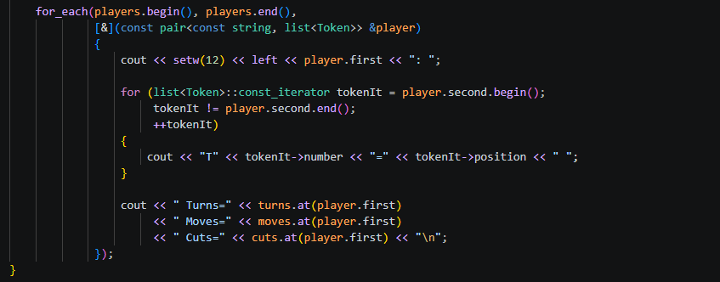

Version 4: Final Full STL Ludo Version

Version 4 is the final and most complete version.

This version fully redesigns the old CIS 5 Ludo project as a CIS 17C STL project.

It removes vector.

It uses STL containers required by the checklist:

List

Map

Set

Queue

Stack

Deque

It includes:

2–4 players

two tokens per player

dice rolling

queue-based turn order

safe tiles

cut rule

triple-six penalty

move history

file logging

final statistics

Leaderboard

STL algorithms

It uses structures/classes for better organization:

Token

Player

Move

ScoreRow

Difference:

Version 0.1 uses parallel arrays.

Version 4 groups player data into a Player structure.

Version 0.1 manually sorts arrays.

Version 4 sorts a deque leaderboard using STL-style organization.

Version 0.1 is procedural.

Version 4 is structured around STL containers and data objects.

Pseudocode:

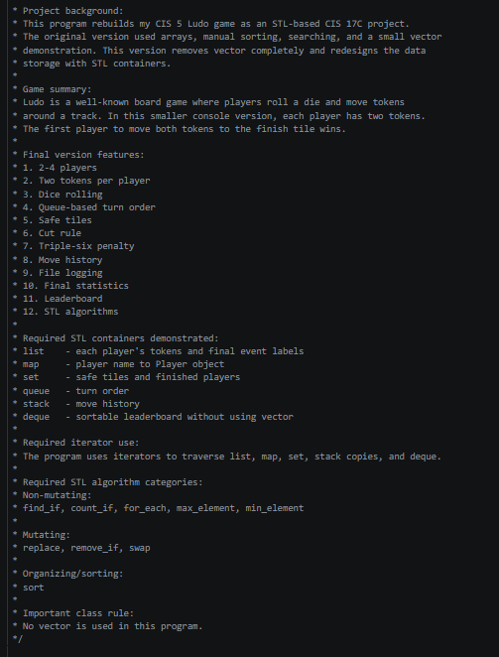

Code Snippet:
Individual Player statistics:

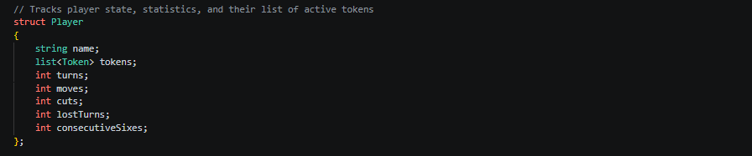
STL leaderboard style:

Final STL algorithm idea:
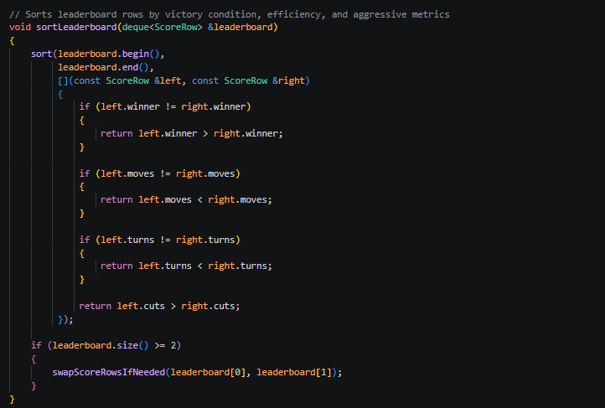

How to Play Ludo (Final Version Instructions)

Welcome to Ludo: CIS 17C STL Edition.

How to Play:

This game supports 2-4 players. Each player has two tokens that begin at tile 0, which represents home.

On your turn, press Enter to roll a die from 1 to 6. After rolling, choose which of your two tokens to move. The token moves forward by the number rolled.

Special Rules:

Cut Rule: If your token lands on another player’s token, the opponent’s token is sent back to tile 0.

Safe Tiles: Some tiles are protected safe tiles. Tokens on safe tiles cannot be cut.

Safe-Stop Rule: Tokens cannot move past tile 50. If a move would go beyond tile 50, the token stops at 50.

Triple-Six Penalty: If a player rolls three sixes in a row, that player loses the turn.

The first player to get both tokens to tile 50 wins.

Every move, roll, cut, penalty, and final result is logged to a file. The final version also displays player statistics, recent move history, and a leaderboard at the end of the game.

Sample Game Screen:

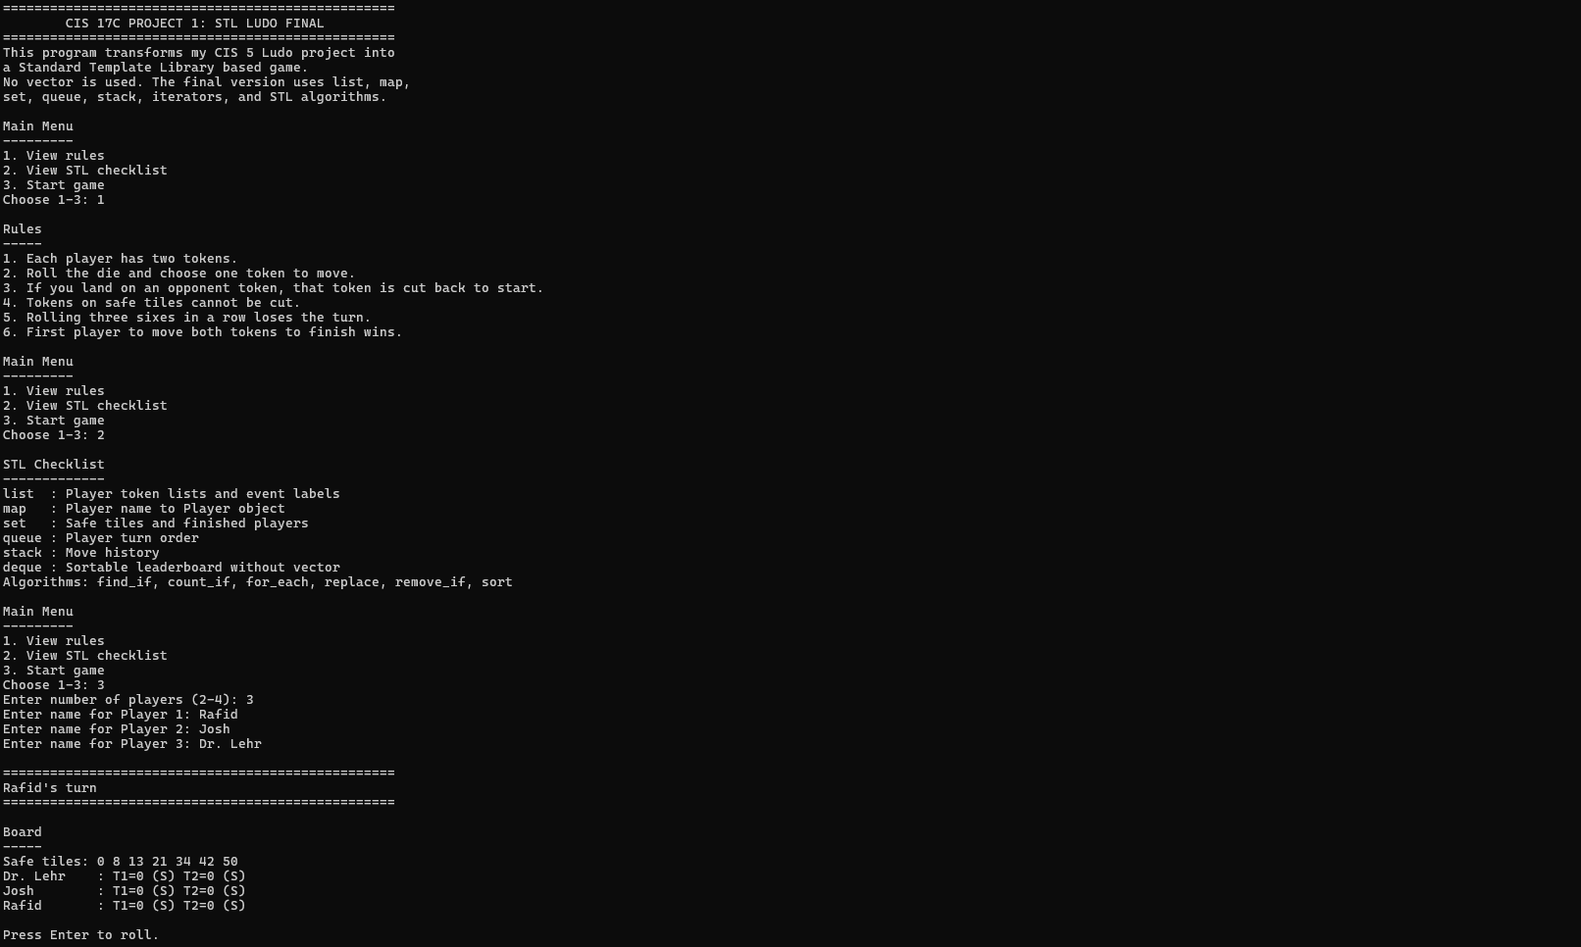

Code Organization: Final Version

1. Header Comment / Project Introduction
/*
* File: Ludo_STL_V4_Final.cpp
* Author: Rafid Sarowar
* Purpose: CIS 17C Project 1 - Final STL Ludo Version
*

- Explains the file name, author, and purpose.
- States that the project rebuilds the old CIS 5 Ludo game as a CIS 17C STL project.
- Explains that vector was removed and replaced with STL containers like list, map, set, queue, stack, and deque.

2. Library Includes

#include <algorithm>
#include <ctime>
#include <cstdlib>
#include <deque>
#include <fstream>
#include <iomanip>
#include <iostream>
#include <list>
#include <map>
#include <queue>
#include <set>
#include <sstream>
#include <stack>
#include <string>

- These libraries support the whole program.
- Important STL libraries:
  - <list> for player tokens
  - <map> for player storage
  - <set> for safe tiles and finished players
  - <queue> for turn order
  - <stack> for move history
  - <deque> for the leaderboard
  - <algorithm> for STL algorithms like sort, find_if, count_if, replace, and remove_if

3. Global Constants

const int START = 0;
const int FINISH = 50;
const int TOKENS = 2;
const int MIN_PLAYERS = 2;
const int MAX_PLAYERS = 4;
const int HISTORY_PREVIEW = 5;

- These constants control the basic game settings.
- START is where tokens begin.
- FINISH is the winning tile.
- TOKENS means each player has 2 tokens.
- MIN_PLAYERS and MAX_PLAYERS control the number of players.
- HISTORY_PREVIEW controls how many recent moves are shown.

4. Struct / Class Section
Your program uses structs instead of full classes. For the write-up, you can call this the Classes / Data Structures section.

Struct 1: Token
// Represents an individual game piece on the board
struct Token
{
int number;
int position;
bool finished;
};

Purpose
- Represents one game piece/token.
- Each player has a list<Token>.
- Stores the token number, board position, and whether the token has finished.

Data Members
- number
  - Identifies token 1 or token 2.
- position
  - Stores where the token is on the board.
- finished
  - Tracks whether the token reached tile 50.

Struct 2: Player
struct Player
{
string name;
list<Token> tokens;
int turns;
int moves;
int cuts;
int lostTurns;
int consecutiveSixes;
};

Purpose
- Stores all information for one player.
- Replaces the old CIS 5 parallel arrays.

Data Members
- name
  - Player’s name.
- tokens
  - A list<Token> containing that player’s two tokens.
- turns
  - Number of turns taken.
- moves
  - Number of successful moves.
- cuts
  - Number of opponent tokens cut.
- lostTurns
  - Number of turns lost from the triple-six penalty.
- consecutiveSixes
  - Tracks how many sixes the player rolled in a row.

Struct 3: Move
struct Move
{
string player;
int tokenNumber;
int roll;
int fromPosition;
int toPosition;
int cutsMade;
string note;
};

Purpose
- Stores one move in the game.
- Used with stack<Move> for move history.
- Also used for file logging.

Data Members
- player
  - Name of the player who moved.
- tokenNumber
  - Which token was moved.
- roll
  - Dice roll value.
- fromPosition
  - Starting position before the move.
- toPosition
  - Ending position after the move.
- cutsMade
  - Number of opponent tokens cut by the move.
- note
  - Extra message, such as “Normal move,” “Token reached finish,” or “Triple-six penalty.”

Struct 4: ScoreRow
struct ScoreRow
{
string name;
int moves;
int turns;
int cuts;
bool winner;
};

Purpose
- Represents one row in the final leaderboard.
- Stored inside a deque<ScoreRow>.

Data Members
- name
  - Player’s name.
- moves
  - Total moves.
- turns
  - Total turns.
- cuts
  - Total cuts.
- winner
  - Whether the player won.

5. Function Prototype Section
int rollDie();
int readIntInRange(const string &prompt, int low, int high);
void waitForEnter();
void showIntro();
void showRules();
void showStlChecklist();
void showMainMenu();
- This section lists all functions before main().
- It shows that the program is modular.
- Each function has a specific purpose.
- This makes the program easier to read and debug.

6. Main Function Organization
The main() function controls the full game flow.

Main Setup
map<string, Player> players;
queue<string> turnOrder;
stack<Move> moveHistory;
set<int> safeTiles = buildSafeTiles();
set<string> finishedPlayers;

Purpose
- Creates the main STL containers used by the game.
- players stores all player objects.
- turnOrder controls whose turn is next.
- moveHistory stores previous moves.
- safeTiles stores safe board spaces.
- finishedPlayers stores players who have finished.

Main Game Loop
while (!gameOver && anyActivePlayers(turnOrder))
{
string currentPlayer = turnOrder.front();
turnOrder.pop();

if (finishedPlayers.find(currentPlayer) != finishedPlayers.end())
{
continue;
}

Player &player = players[currentPlayer];
player.turns++;

Purpose
- Runs the game until someone wins.
- Uses a queue to decide whose turn it is.
- Updates the current player’s turn count.

End Game Section
deque<ScoreRow> leaderboard = buildLeaderboard(players, finishedPlayers);
sortLeaderboard(leaderboard);
printLeaderboard(leaderboard);
saveLeaderboard(leaderboard);

runAlgorithmReport(players, finishedPlayers, moveHistory);
writeFinalLog(logFile, players, finishedPlayers, moveHistory);

Purpose
- Builds the leaderboard.
- Sorts the leaderboard.
- Prints and saves results.
- Runs the STL algorithm report.
- Writes the final game log.

7. Function Groups

A. Input / Menu Functions
- readIntInRange()
- waitForEnter()
- showIntro()
- showRules()
- showStlChecklist()
- showMainMenu()

Purpose
- Handles user input.
- Displays instructions.
- Displays the rules.
- Displays the STL checklist.
- Starts the game.

B. Player Setup Functions
- buildPlayers()
- addPlayer()
- initializeTokens()

Purpose
- Creates players.
- Adds players to the map.
- Adds player names to the queue.
- Gives each player two tokens.

C. Board / Display Functions
- buildSafeTiles()
- isSafeTile()
- printSafeTiles()
- printBoard()
- printOnePlayer()
- printStats()

Purpose
- Builds the safe tile set.
- Checks whether a tile is safe.
- Prints the board.
- Prints player stats.

D. Game Logic Functions
- rollDie()
- findToken()
- findTokenConst()
- moveToken()
- applyCuts()
- playerHasWon()
- anyActivePlayers()

Purpose
- Rolls the die.
- Finds the selected token.
- Moves the token.
- Applies the cut rule.
- Checks for a winner.
- Checks if the game still has active players.

E. Move History Functions
- makeMove()
- moveToString()
- printMove()
- printHistoryPreview()

Purpose
- Creates a Move object.
- Converts a move into readable text.
- Prints one move.
- Shows recent moves from the stack.

F. File Logging Functions
- writeLogHeader()
- writeMoveLog()
- writeFinalLog()

Purpose
- Writes the game start information.
- Logs each move.
- Logs final results.

G. Leaderboard Functions
- buildLeaderboard()
- sortLeaderboard()
- printLeaderboard()
- saveLeaderboard()
- swapScoreRowsIfNeeded()

Purpose
- Builds the leaderboard using deque<ScoreRow>.
- Sorts the leaderboard.
- Prints the leaderboard.
- Saves the leaderboard to a file.
- Demonstrates swap.

H. Algorithm / Statistics Functions
- runAlgorithmReport()
- buildEventLabels()
- cleanEventLabels()
- countFinishedTokens()
- countTokensAtStart()
- countTokensOnBoard()
- countAllCuts()
- countAllMoves()
- averageMoves()
- bestCutterName()
- mostEfficientName()

Purpose
- Demonstrates STL algorithms.
- Counts finished tokens.
- Counts tokens at start.
- Counts total moves and cuts.
- Calculates average moves.
- Finds the best cutter.
- Finds the most efficient player.

Checkoff Sheet Contents
- Sequence Container: list - list<Token> tokens in Player struct — around line 92.
- Sequence Container: slist - Not used.
- Sequence Container: bit_vector - Not used.
- Associative Container: map - map<string, Player> players — around line 188.
- Associative Container: set - set<int> safeTiles, set<string> finishedPlayers — around lines 191–192.
- Associative Container: hash - Not used.
- Container Adaptor: stack - stack<Move> moveHistory — around line 190.
- Container Adaptor: queue - queue<string> turnOrder — around line 189.
- Container Adaptor: priority_queue - Not used.
- Extra Container: deque - deque<ScoreRow> leaderboard — around line 332.

Iterator Checkoff
- map iterator - map<string, Player>::const_iterator playerIt — around lines 599–601, 808–810, 840–842, 870–872.
- list iterator - list<Token>::const_iterator tokenIt — around lines 563–565.
- list iterator with find_if - list<Token>::iterator tokenIt — around lines 645–650.
- set iterator - set<int>::const_iterator safeIt — around lines 535–537, 817–819.
- set<string> iterator - set<string>::const_iterator finishedIt — around lines 855–857.
- deque iterator - deque<ScoreRow>::const_iterator rowIt — around lines 928–930, 954–956.
- deque random access iterator - used with sort, min_element, and max_element — around lines 889–909, 991–1003.
- stack access - uses top() and pop() instead of normal iterators — around lines 629–633, 1016–1022.

Algorithms
- Non-mutating Algorithm: for_each - used in printBoard() — around lines 551–556.
- Non-mutating Algorithm: find_if - used in findToken() and findTokenConst() — around lines 645–650, 663–668.
- Non-mutating Algorithm: count_if - used in token-counting functions — around lines 1072–1077, 1083–1088, 1094–1099.
- Non-mutating Algorithm: max_element - finds player with most cuts — around lines 991–996.
- Non-mutating Algorithm: min_element - finds player with fewest moves — around lines 998–1003.
- Mutating Algorithm: replace - used in cleanEventLabels() — around line 1057.
- Mutating Algorithm: remove_if - used in cleanEventLabels() — around lines 1059–1064.
- Mutating Algorithm: swap - used in swapScoreRowsIfNeeded() — around line 1189.
- Organization Algorithm: sort - used in sortLeaderboard() — around lines 889–909.
- Organization: Minimum and Maximum - min_element and max_element — around lines 991–1003.

Version 4/Final Version
/*
* File: Ludo_STL_V4_Final.cpp
* Author: Rafid Sarowar
* Purpose: CIS 17C Project 1 - Final STL Ludo Version
*
* Project background:
* This program rebuilds my CIS 5 Ludo game as an STL-based CIS 17C project.
* The original version used arrays, manual sorting, searching, and a small vector
* demonstration. This version removes vector completely and redesigns the data
* storage with STL containers.
*
* Game summary:
* Ludo is a well-known board game where players roll a die and move tokens
* around a track. In this smaller console version, each player has two tokens.
* The first player to move both tokens to the finish tile wins.
*
* Final version features:
* 1. 2-4 players
* 2. Two tokens per player
* 3. Dice rolling
* 4. Queue-based turn order
* 5. Safe tiles
* 6. Cut rule
* 7. Triple-six penalty
* 8. Move history
* 9. File logging
* 10. Final statistics
* 11. Leaderboard
* 12. STL algorithms
*
* Required STL containers demonstrated:
* list - each player's tokens and final event labels
* map - player name to Player object
* set - safe tiles and finished players
* queue - turn order
* stack - move history
* deque - sortable leaderboard without using vector
*
* Required iterator use:
* The program uses iterators to traverse list, map, set, stack copies, and deque.
*
* Required STL algorithm categories:
* Non-mutating:
* find_if, count_if, for_each, max_element, min_element
*
* Mutating:
* replace, remove_if, swap
*
* Organizing/sorting:
* sort
*
* Important class rule:
* No vector is used in this program.
*/

#include <algorithm>
#include <ctime>
#include <cstdlib>
#include <deque>
#include <fstream>
#include <iomanip>
#include <iostream>
#include <list>
#include <map>
#include <queue>
#include <set>
#include <sstream>
#include <stack>
#include <string>

using namespace std;

const int START = 0;
const int FINISH = 50;
const int TOKENS = 2;
const int MIN_PLAYERS = 2;
const int MAX_PLAYERS = 4;
const int HISTORY_PREVIEW = 5;

// Represents an individual game piece on the board
struct Token
{
int number;
int position;
bool finished;
};

// Tracks player state, statistics, and their list of active tokens
struct Player
{
string name;
list<Token> tokens;
int turns;
int moves;
int cuts;
int lostTurns;
int consecutiveSixes;
};

// Records the details of a single move for game history logging
struct Move
{
string player;
int tokenNumber;
int roll;
int fromPosition;
int toPosition;
int cutsMade;
string note;
};

// Structured data used to generate and sort the post-game leaderboard row
struct ScoreRow
{
string name;
int moves;
int turns;
int cuts;
bool winner;
};

int rollDie();
int readIntInRange(const string &prompt, int low, int high);
void waitForEnter();
void showIntro();
void showRules();
void showStlChecklist();
void showMainMenu();
void buildPlayers(map<string, Player> &players, queue<string> &turnOrder);
void addPlayer(map<string, Player> &players, queue<string> &turnOrder, const string &name);
void initializeTokens(Player &player);
set<int> buildSafeTiles();
bool isSafeTile(const set<int> &safeTiles, int position);
void printSafeTiles(const set<int> &safeTiles);
void printBoard(const map<string, Player> &players, const set<int> &safeTiles);
void printOnePlayer(const Player &player, const set<int> &safeTiles);
void printStats(const map<string, Player> &players);
void printHistoryPreview(stack<Move> history);
void printMove(const Move &move);
Token *findToken(list<Token> &tokens, int tokenNumber);
const Token *findTokenConst(const list<Token> &tokens, int tokenNumber);
bool moveToken(Player &player, int tokenNumber, int roll, int &oldPosition, int &newPosition);
int applyCuts(map<string, Player> &players,
const string &currentPlayer,
int landingPosition,
const set<int> &safeTiles);
bool playerHasWon(const Player &player);
bool anyActivePlayers(const queue<string> &turnOrder);
Move makeMove(const string &playerName,
int tokenNumber,
int roll,
int oldPosition,
int newPosition,
int cutsMade,
const string &note);
string moveToString(const Move &move);
void writeLogHeader(ofstream &logFile, const map<string, Player> &players, const set<int> &safeTiles);
void writeMoveLog(ofstream &logFile, const Move &move);
void writeFinalLog(ofstream &logFile,
const map<string, Player> &players,
const set<string> &finishedPlayers,
const stack<Move> &history);
deque<ScoreRow> buildLeaderboard(const map<string, Player> &players, const set<string> &finishedPlayers);
void sortLeaderboard(deque<ScoreRow> &leaderboard);
void printLeaderboard(const deque<ScoreRow> &leaderboard);
void saveLeaderboard(const deque<ScoreRow> &leaderboard);
void runAlgorithmReport(const map<string, Player> &players,
const set<string> &finishedPlayers,
stack<Move> history);
list<string> buildEventLabels(const map<string, Player> &players,
const set<string> &finishedPlayers);
void cleanEventLabels(list<string> &labels);
int countFinishedTokens(const Player &player);
int countTokensAtStart(const Player &player);
int countTokensOnBoard(const Player &player);
int countAllCuts(const map<string, Player> &players);
int countAllMoves(const map<string, Player> &players);
float averageMoves(const map<string, Player> &players);
string bestCutterName(const map<string, Player> &players);
string mostEfficientName(const map<string, Player> &players);
void swapScoreRowsIfNeeded(ScoreRow &left, ScoreRow &right);

// Core game execution loop handling game state initialization, turns, and game over sequences
int main()
{
srand(static_cast<unsigned int>(time(0)));

map<string, Player> players;
queue<string> turnOrder;
stack<Move> moveHistory;
set<int> safeTiles = buildSafeTiles();
set<string> finishedPlayers;

ofstream logFile("ludo_stl_v4_final_log.txt");
if (!logFile)
{
cout << "Error: could not open ludo_stl_v4_final_log.txt\n";
return 1;
}

showIntro();
showMainMenu();
buildPlayers(players, turnOrder);
writeLogHeader(logFile, players, safeTiles);

bool gameOver = false;
string winner = "";

while (!gameOver && anyActivePlayers(turnOrder))
{
string currentPlayer = turnOrder.front();
turnOrder.pop();

if (finishedPlayers.find(currentPlayer) != finishedPlayers.end())
{
continue;
}

Player &player = players[currentPlayer];
player.turns++;

cout << "\n==================================================\n";
cout << player.name << "'s turn\n";
cout << "==================================================\n";
printBoard(players, safeTiles);
cout << "\nPress Enter to roll.";
waitForEnter();

int roll = rollDie();
cout << player.name << " rolled " << roll << ".\n";

if (roll == 6)
{
player.consecutiveSixes++;
if (player.consecutiveSixes >= 3)
{
player.lostTurns++;
player.consecutiveSixes = 0;
Move penalty = makeMove(player.name,
0,
roll,
START,
START,
0,
"Triple-six penalty: turn lost.");
moveHistory.push(penalty);
writeMoveLog(logFile, penalty);
cout << "Three consecutive sixes. Turn lost.\n";
turnOrder.push(currentPlayer);
continue;
}
}
else
{
player.consecutiveSixes = 0;
}

int tokenChoice = readIntInRange("Choose token 1 or 2: ", 1, TOKENS);

int oldPosition = START;
int newPosition = START;
bool moved = moveToken(player, tokenChoice, roll, oldPosition, newPosition);

if (!moved)
{
Move failed = makeMove(player.name,
tokenChoice,
roll,
oldPosition,
newPosition,
0,
"Invalid token choice.");
moveHistory.push(failed);
writeMoveLog(logFile, failed);
cout << "The token could not be moved.\n";
turnOrder.push(currentPlayer);
continue;
}

player.moves++;

int cutsMade = applyCuts(players, currentPlayer, newPosition, safeTiles);
player.cuts += cutsMade;

string note = "Normal move.";
if (newPosition == FINISH)
{
note = "Token reached finish.";
}
else if (isSafeTile(safeTiles, newPosition))
{
note = "Token landed on a safe tile.";
}
else if (cutsMade > 0)
{
note = "Move cut opponent token(s).";
}

Move move = makeMove(player.name,
tokenChoice,
roll,
oldPosition,
newPosition,
cutsMade,
note);

moveHistory.push(move);
writeMoveLog(logFile, move);
printMove(move);
printHistoryPreview(moveHistory);

if (playerHasWon(player))
{
finishedPlayers.insert(currentPlayer);
winner = currentPlayer;
gameOver = true;
}
else
{
turnOrder.push(currentPlayer);
}
}

cout << "\n==================================================\n";
cout << "Game Over\n";
cout << "==================================================\n";
cout << "Winner: " << winner << "\n";

printBoard(players, safeTiles);
printStats(players);

deque<ScoreRow> leaderboard = buildLeaderboard(players, finishedPlayers);
sortLeaderboard(leaderboard);
printLeaderboard(leaderboard);
saveLeaderboard(leaderboard);

runAlgorithmReport(players, finishedPlayers, moveHistory);
writeFinalLog(logFile, players, finishedPlayers, moveHistory);

cout << "\nFinal version complete. Results were saved to:\n";
cout << " ludo_stl_v4_final_log.txt\n";
cout << " ludo_stl_v4_leaderboard.txt\n";

return 0;
}

// Simulates a standard 6-sided die roll
int rollDie()
{
return rand() % 6 + 1;
}

// Prompts user for numerical input within specific bounds, with type validation
int readIntInRange(const string &prompt, int low, int high)
{
int value = low - 1;
bool valid = false;

while (!valid)
{
cout << prompt;
cin >> value;

if (cin.fail())
{
cin.clear();
cin.ignore(1000, '\n');
cout << "Please enter a number.\n";
}
else if (value < low || value > high)
{
cin.ignore(1000, '\n');
cout << "Please enter a value from " << low << " to " << high << ".\n";
}
else
{
cin.ignore(1000, '\n');
valid = true;
}
}

return value;
}

void waitForEnter()
{
cin.ignore(1000, '\n');
}

void showIntro()
{
cout << "==================================================\n";
cout << " CIS 17C PROJECT 1: STL LUDO FINAL\n";
cout << "==================================================\n";
cout << "This program transforms my CIS 5 Ludo project into\n";
cout << "a Standard Template Library based game.\n";
cout << "No vector is used. The final version uses list, map,\n";
cout << "set, queue, stack, iterators, and STL algorithms.\n";
}

void showRules()
{
cout << "\nRules\n";
cout << "-----\n";
cout << "1. Each player has two tokens.\n";
cout << "2. Roll the die and choose one token to move.\n";
cout << "3. If you land on an opponent token, that token is cut back to start.\n";
cout << "4. Tokens on safe tiles cannot be cut.\n";
cout << "5. Rolling three sixes in a row loses the turn.\n";
cout << "6. First player to move both tokens to finish wins.\n";
}

void showStlChecklist()
{
cout << "\nSTL Checklist\n";
cout << "-------------\n";
cout << "list : Player token lists and event labels\n";
cout << "map : Player name to Player object\n";
cout << "set : Safe tiles and finished players\n";
cout << "queue : Player turn order\n";
cout << "stack : Move history\n";
cout << "deque : Sortable leaderboard without vector\n";
cout << "Algorithms: find_if, count_if, for_each, replace, remove_if, sort\n";
}

void showMainMenu()
{
bool done = false;
while (!done)
{
cout << "\nMain Menu\n";
cout << "---------\n";
cout << "1. View rules\n";
cout << "2. View STL checklist\n";
cout << "3. Start game\n";

int choice = readIntInRange("Choose 1-3: ", 1, 3);

if (choice == 1)
{
showRules();
}
else if (choice == 2)
{
showStlChecklist();
}
else
{
done = true;
}
}
}

// Configures player map entries and sets the initial queue turn layout
void buildPlayers(map<string, Player> &players, queue<string> &turnOrder)
{
int playerCount = readIntInRange("Enter number of players (2-4): ",
MIN_PLAYERS,
MAX_PLAYERS);

for (int i = 1; i <= playerCount; ++i)
{
string name;
cout << "Enter name for Player " << i << ": ";
getline(cin, name);

if (name.empty())
{
ostringstream fallback;
fallback << "Player" << i;
name = fallback.str();
}

while (players.find(name) != players.end())
{
cout << "That name is already used. Enter another name: ";
getline(cin, name);
}

addPlayer(players, turnOrder, name);
}
}

// Populates structural values for a single player entity
void addPlayer(map<string, Player> &players, queue<string> &turnOrder, const string &name)
{
Player player;
player.name = name;
player.turns = 0;
player.moves = 0;
player.cuts = 0;
player.lostTurns = 0;
player.consecutiveSixes = 0;
initializeTokens(player);

players[name] = player;
turnOrder.push(name);
}

// Generates token instances tied to the designated start configuration
void initializeTokens(Player &player)
{
for (int tokenNumber = 1; tokenNumber <= TOKENS; ++tokenNumber)
{
Token token;
token.number = tokenNumber;
token.position = START;
token.finished = false;
player.tokens.push_back(token);
}
}

// Loads coordinates assigned as safe spaces into an STL set container
set<int> buildSafeTiles()
{
set<int> safeTiles;
safeTiles.insert(START);
safeTiles.insert(8);
safeTiles.insert(13);
safeTiles.insert(21);
safeTiles.insert(34);
safeTiles.insert(42);
safeTiles.insert(FINISH);
return safeTiles;
}

bool isSafeTile(const set<int> &safeTiles, int position)
{
return safeTiles.find(position) != safeTiles.end();
}

void printSafeTiles(const set<int> &safeTiles)
{
cout << "Safe tiles: ";
for (set<int>::const_iterator safeIt = safeTiles.begin();
safeIt != safeTiles.end();
++safeIt)
{
cout << *safeIt << " ";
}
cout << "\n";
}

// Iterates across structural fields using for_each to display individual token layouts
void printBoard(const map<string, Player> &players, const set<int> &safeTiles)
{
cout << "\nBoard\n";
cout << "-----\n";
printSafeTiles(safeTiles);

for_each(players.begin(),
players.end(),
[&](const pair<const string, Player> &entry)
{
printOnePlayer(entry.second, safeTiles);
});
}

void printOnePlayer(const Player &player, const set<int> &safeTiles)
{
cout << setw(12) << left << player.name << ": ";

for (list<Token>::const_iterator tokenIt = player.tokens.begin();
tokenIt != player.tokens.end();
++tokenIt)
{
cout << "T" << tokenIt->number << "=" << setw(2) << tokenIt->position;

if (tokenIt->finished)
{
cout << "(F) ";
}
else if (isSafeTile(safeTiles, tokenIt->position))
{
cout << "(S) ";
}
else
{
cout << " ";
}
}

cout << "\n";
}

void printStats(const map<string, Player> &players)
{
cout << "\nPlayer Statistics\n";
cout << "-----------------\n";
cout << left << setw(12) << "Player"
<< right << setw(8) << "Turns"
<< setw(8) << "Moves"
<< setw(8) << "Cuts"
<< setw(10) << "Lost"
<< setw(11) << "AtStart"
<< setw(10) << "Done"
<< "\n";

for (map<string, Player>::const_iterator playerIt = players.begin();
playerIt != players.end();
++playerIt)
{
const Player &player = playerIt->second;
cout << left << setw(12) << player.name
<< right << setw(8) << player.turns
<< setw(8) << player.moves
<< setw(8) << player.cuts
<< setw(10) << player.lostTurns
<< setw(11) << countTokensAtStart(player)
<< setw(10) << countFinishedTokens(player)
<< "\n";
}

cout << fixed << setprecision(2);
cout << "Average moves: " << averageMoves(players) << "\n";
cout << "Total moves : " << countAllMoves(players) << "\n";
cout << "Total cuts : " << countAllCuts(players) << "\n";
cout << "Best cutter : " << bestCutterName(players) << "\n";
cout << "Efficient : " << mostEfficientName(players) << "\n";
}

// Prints a shallow preview log using a localized stack duplicate structure
void printHistoryPreview(stack<Move> history)
{
cout << "\nRecent Move History\n";
cout << "-------------------\n";

int shown = 0;
while (!history.empty() && shown < HISTORY_PREVIEW)
{
printMove(history.top());
history.pop();
++shown;
}
}

void printMove(const Move &move)
{
cout << moveToString(move) << "\n";
}

// Utilizes find_if to scan a token list dynamically for matching identifiers
Token *findToken(list<Token> &tokens, int tokenNumber)
{
list<Token>::iterator tokenIt = find_if(tokens.begin(),
tokens.end(),
[tokenNumber](const Token &token)
{
return token.number == tokenNumber;
});

if (tokenIt == tokens.end())
{
return 0;
}

return &(*tokenIt);
}

// Constant variant of token query algorithm using target pointer structures
const Token *findTokenConst(const list<Token> &tokens, int tokenNumber)
{
list<Token>::const_iterator tokenIt = find_if(tokens.begin(),
tokens.end(),
[tokenNumber](const Token &token)
{
return token.number == tokenNumber;
});

if (tokenIt == tokens.end())
{
return 0;
}

return &(*tokenIt);
}

// Processes internal token space additions and checks endpoint boundaries
bool moveToken(Player &player, int tokenNumber, int roll, int &oldPosition, int &newPosition)
{
Token *token = findToken(player.tokens, tokenNumber);

if (token == 0)
{
return false;
}

oldPosition = token->position;

if (token->finished)
{
newPosition = token->position;
return true;
}

token->position += roll;
if (token->position >= FINISH)
{
token->position = FINISH;
token->finished = true;
}

newPosition = token->position;
return true;
}

// Compares land positions against competitor entities to capture and reset tracking items
int applyCuts(map<string, Player> &players,
const string &currentPlayer,
int landingPosition,
const set<int> &safeTiles)
{
if (landingPosition == START || landingPosition == FINISH || isSafeTile(safeTiles, landingPosition))
{
return 0;
}

int cutCount = 0;

for (map<string, Player>::iterator playerIt = players.begin();
playerIt != players.end();
++playerIt)
{
if (playerIt->first != currentPlayer)
{
Player &opponent = playerIt->second;

for (list<Token>::iterator tokenIt = opponent.tokens.begin();
tokenIt != opponent.tokens.end();
++tokenIt)
{
if (tokenIt->position == landingPosition && !tokenIt->finished)
{
tokenIt->position = START;
tokenIt->finished = false;
++cutCount;
cout << "Cut " << opponent.name << "'s token "
<< tokenIt->number << " back to start.\n";
}
}
}
}

return cutCount;
}

bool playerHasWon(const Player &player)
{
int finishedCount = countFinishedTokens(player);
return finishedCount == TOKENS;
}

bool anyActivePlayers(const queue<string> &turnOrder)
{
return !turnOrder.empty();
}

Move makeMove(const string &playerName,
int tokenNumber,
int roll,
int oldPosition,
int newPosition,
int cutsMade,
const string &note)
{
Move move;
move.player = playerName;
move.tokenNumber = tokenNumber;
move.roll = roll;
move.fromPosition = oldPosition;
move.toPosition = newPosition;
move.cutsMade = cutsMade;
move.note = note;
return move;
}

string moveToString(const Move &move)
{
ostringstream out;
out << move.player;

if (move.tokenNumber > 0)
{
out << " moved token " << move.tokenNumber
<< " from " << move.fromPosition
<< " to " << move.toPosition
<< " after rolling " << move.roll;
}
else
{
out << " rolled " << move.roll;
}

if (move.cutsMade > 0)
{
out << " and made " << move.cutsMade << " cut(s)";
}

out << ". " << move.note;
return out.str();
}

void writeLogHeader(ofstream &logFile, const map<string, Player> &players, const set<int> &safeTiles)
{
logFile << "CIS 17C STL Ludo Final Log\n";
logFile << "Players: ";

for (map<string, Player>::const_iterator playerIt = players.begin();
playerIt != players.end();
++playerIt)
{
logFile << playerIt->first << " ";
}

logFile << "\nSafe tiles: ";

for (set<int>::const_iterator safeIt = safeTiles.begin();
safeIt != safeTiles.end();
++safeIt)
{
logFile << *safeIt << " ";
}

logFile << "\n\n";
}

void writeMoveLog(ofstream &logFile, const Move &move)
{
logFile << moveToString(move) << "\n";
}

void writeFinalLog(ofstream &logFile,
const map<string, Player> &players,
const set<string> &finishedPlayers,
const stack<Move> &history)
{
logFile << "\nFinal Stats\n";
logFile << "-----------\n";

for (map<string, Player>::const_iterator playerIt = players.begin();
playerIt != players.end();
++playerIt)
{
const Player &player = playerIt->second;
logFile << player.name
<< " turns=" << player.turns
<< " moves=" << player.moves
<< " cuts=" << player.cuts
<< " lost=" << player.lostTurns
<< " finishedTokens=" << countFinishedTokens(player)
<< "\n";
}

logFile << "\nFinished players: ";
for (set<string>::const_iterator finishedIt = finishedPlayers.begin();
finishedIt != finishedPlayers.end();
++finishedIt)
{
logFile << *finishedIt << " ";
}

logFile << "\nMove history size: " << history.size() << "\n";
}

// Maps player metrics onto an indexable, non-vector linear deque container
deque<ScoreRow> buildLeaderboard(const map<string, Player> &players, const set<string> &finishedPlayers)
{
deque<ScoreRow> leaderboard;

for (map<string, Player>::const_iterator playerIt = players.begin();
playerIt != players.end();
++playerIt)
{
ScoreRow row;
row.name = playerIt->second.name;
row.moves = playerIt->second.moves;
row.turns = playerIt->second.turns;
row.cuts = playerIt->second.cuts;
row.winner = finishedPlayers.find(row.name) != finishedPlayers.end();
leaderboard.push_back(row);
}

return leaderboard;
}

// Sorts leaderboard rows by victory condition, efficiency, and aggressive metrics
void sortLeaderboard(deque<ScoreRow> &leaderboard)
{
sort(leaderboard.begin(),
leaderboard.end(),
[](const ScoreRow &left, const ScoreRow &right)
{
if (left.winner != right.winner)
{
return left.winner > right.winner;
}

if (left.moves != right.moves)
{
return left.moves < right.moves;
}

if (left.turns != right.turns)
{
return left.turns < right.turns;
}

return left.cuts > right.cuts;
});

if (leaderboard.size() >= 2)
{
swapScoreRowsIfNeeded(leaderboard[0], leaderboard[1]);
}
}

void printLeaderboard(const deque<ScoreRow> &leaderboard)
{
cout << "\nLeaderboard\n";
cout << "-----------\n";
cout << left << setw(12) << "Player"
<< right << setw(8) << "Moves"
<< setw(8) << "Turns"
<< setw(8) << "Cuts"
<< setw(10) << "Winner"
<< "\n";

for (deque<ScoreRow>::const_iterator rowIt = leaderboard.begin();
rowIt != leaderboard.end();
++rowIt)
{
cout << left << setw(12) << rowIt->name
<< right << setw(8) << rowIt->moves
<< setw(8) << rowIt->turns
<< setw(8) << rowIt->cuts
<< setw(10) << (rowIt->winner ? "yes" : "no")
<< "\n";
}
}

void saveLeaderboard(const deque<ScoreRow> &leaderboard)
{
ofstream outFile("ludo_stl_v4_leaderboard.txt", ios::app);

if (!outFile)
{
cout << "Could not save leaderboard.\n";
return;
}

outFile << "Leaderboard\n";
outFile << "-----------\n";

for (deque<ScoreRow>::const_iterator rowIt = leaderboard.begin();
rowIt != leaderboard.end();
++rowIt)
{
outFile << rowIt->name
<< " moves=" << rowIt->moves
<< " turns=" << rowIt->turns
<< " cuts=" << rowIt->cuts
<< " winner=" << (rowIt->winner ? "yes" : "no")
<< "\n";
}

outFile << "\n";
}

// Performs complexity metrics validations using max_element and min_element variations
void runAlgorithmReport(const map<string, Player> &players,
const set<string> &finishedPlayers,
stack<Move> history)
{
cout << "\nSTL Algorithm Report\n";
cout << "--------------------\n";

list<string> labels = buildEventLabels(players, finishedPlayers);
cleanEventLabels(labels);

cout << "Clean event labels: ";
for (list<string>::const_iterator labelIt = labels.begin();
labelIt != labels.end();
++labelIt)
{
cout << "[" << *labelIt << "] ";
}
cout << "\n";

deque<ScoreRow> leaderboard = buildLeaderboard(players, finishedPlayers);

deque<ScoreRow>::iterator maxCutIt = max_element(leaderboard.begin(),
leaderboard.end(),
[](const ScoreRow &left, const ScoreRow &right)
{
return left.cuts < right.cuts;
});

deque<ScoreRow>::iterator minMoveIt = min_element(leaderboard.begin(),
leaderboard.end(),
[](const ScoreRow &left, const ScoreRow &right)
{
return left.moves < right.moves;
});

if (maxCutIt != leaderboard.end())
{
cout << "max_element cuts : " << maxCutIt->name << "\n";
}

if (minMoveIt != leaderboard.end())
{
cout << "min_element moves: " << minMoveIt->name << "\n";
}

int cutMoves = 0;
while (!history.empty())
{
if (history.top().cutsMade > 0)
{
++cutMoves;
}
history.pop();
}

cout << "Move history entries with cuts: " << cutMoves << "\n";
}

// Maps conditional flags into custom dynamic string list elements
list<string> buildEventLabels(const map<string, Player> &players,
const set<string> &finishedPlayers)
{
list<string> labels;

for (map<string, Player>::const_iterator playerIt = players.begin();
playerIt != players.end();
++playerIt)
{
labels.push_back(playerIt->second.moves > 0 ? "played" : "remove-empty");
labels.push_back(playerIt->second.cuts > 0 ? "cutter" : "replace-none");

if (finishedPlayers.find(playerIt->first) != finishedPlayers.end())
{
labels.push_back("winner");
}
else
{
labels.push_back("replace-none");
}
}

return labels;
}

// Demonstrates mutation structures utilizing std::replace and std::remove_if pipelines
void cleanEventLabels(list<string> &labels)
{
replace(labels.begin(), labels.end(), string("replace-none"), string("none"));

list<string>::iterator newEnd = remove_if(labels.begin(),
labels.end(),
[](const string &label)
{
return label == "remove-empty";
});

labels.erase(newEnd, labels.end());
}

// Runs count_if to tally total tokens that have reached the finish tile
int countFinishedTokens(const Player &player)
{
return static_cast<int>(count_if(player.tokens.begin(),
player.tokens.end(),
[](const Token &token)
{
return token.finished;
}));
}

// Runs count_if to tally total tokens currently sitting at the start tile
int countTokensAtStart(const Player &player)
{
return static_cast<int>(count_if(player.tokens.begin(),
player.tokens.end(),
[](const Token &token)
{
return token.position == START;
}));
}

// Runs count_if to tally total active board tokens between start and finish
int countTokensOnBoard(const Player &player)
{
return static_cast<int>(count_if(player.tokens.begin(),
player.tokens.end(),
[](const Token &token)
{
return token.position > START && token.position < FINISH;
}));
}

int countAllCuts(const map<string, Player> &players)
{
int total = 0;

for (map<string, Player>::const_iterator playerIt = players.begin();
playerIt != players.end();
++playerIt)
{
total += playerIt->second.cuts;
}

return total;
}

int countAllMoves(const map<string, Player> &players)
{
int total = 0;

for (map<string, Player>::const_iterator playerIt = players.begin();
playerIt != players.end();
++playerIt)
{
total += playerIt->second.moves;
}

return total;
}

float averageMoves(const map<string, Player> &players)
{
if (players.empty())
{
return 0.0f;
}

return static_cast<float>(countAllMoves(players)) / static_cast<float>(players.size());
}

string bestCutterName(const map<string, Player> &players)
{
if (players.empty())
{
return "none";
}

map<string, Player>::const_iterator bestIt = players.begin();

for (map<string, Player>::const_iterator playerIt = players.begin();
playerIt != players.end();
++playerIt)
{
if (playerIt->second.cuts > bestIt->second.cuts)
{
bestIt = playerIt;
}
}

return bestIt->first;
}

string mostEfficientName(const map<string, Player> &players)
{
if (players.empty())
{
return "none";
}

map<string, Player>::const_iterator bestIt = players.begin();

for (map<string, Player>::const_iterator playerIt = players.begin();
playerIt != players.end();
++playerIt)
{
if (playerIt->second.moves < bestIt->second.moves)
{
bestIt = playerIt;
}
}

return bestIt->first;
}

// Manually swaps element indices using std::swap utility functions
void swapScoreRowsIfNeeded(ScoreRow &left, ScoreRow &right)
{
if (!left.winner && right.winner)
{
swap(left, right);
}
}

Conclusion

In conclusion, this project shows how my original CIS 5 Ludo game developed into a stronger CIS 17C STL-based program. Version 0.1 began as a basic array and function-based game, while later versions gradually replaced manual structures with STL containers, iterators, and algorithms. The final version uses list, map, set, queue, stack, and deque to organize players, tokens, turns, safe tiles, move history, and leaderboard data. It also includes important Ludo rules such as token movement, cutting opponents, safe tiles, the triple-six penalty, file logging, statistics, and final leaderboard output. Overall, this project helped me understand how STL containers and algorithms can make a program more organized, flexible, and easier to maintain.

Flowchart
